**Bash Scripting Task**

1) Create on Bash script to check if a directory is available or not**.**

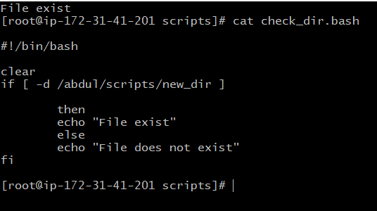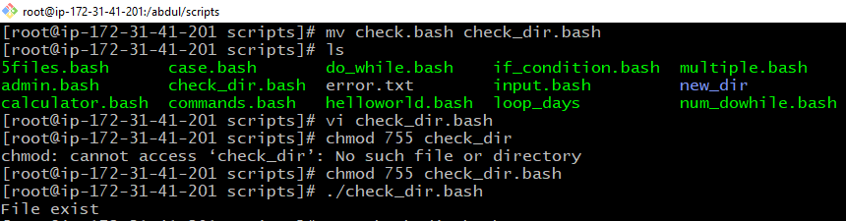

2) Create a bash script which will create multiple files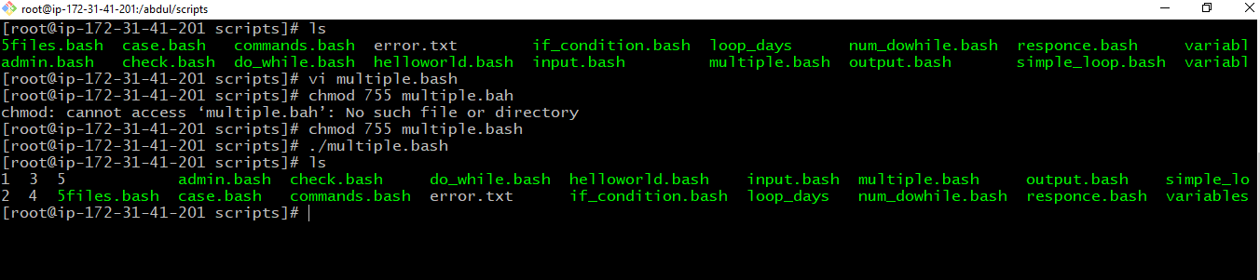

4) Create a bash script to install nginx in ec2 server.

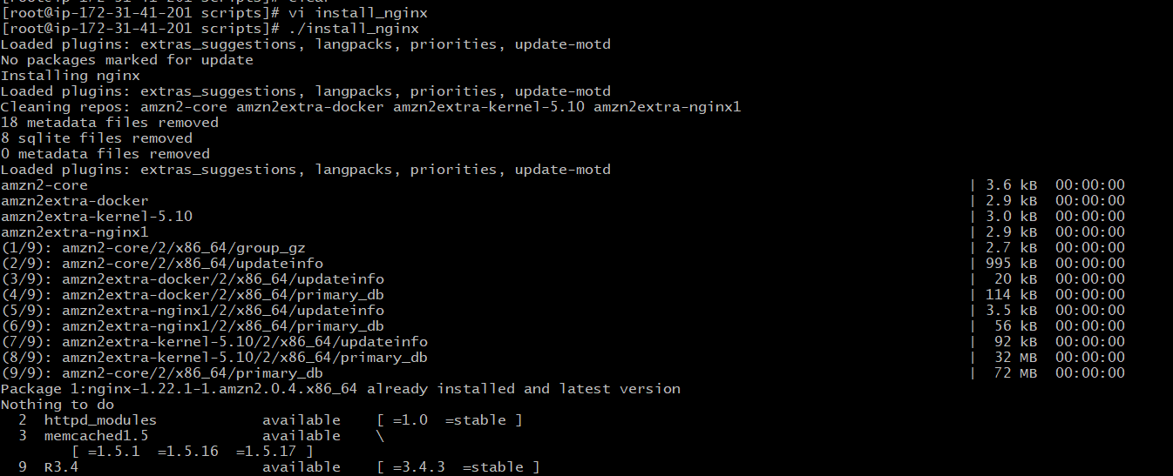  
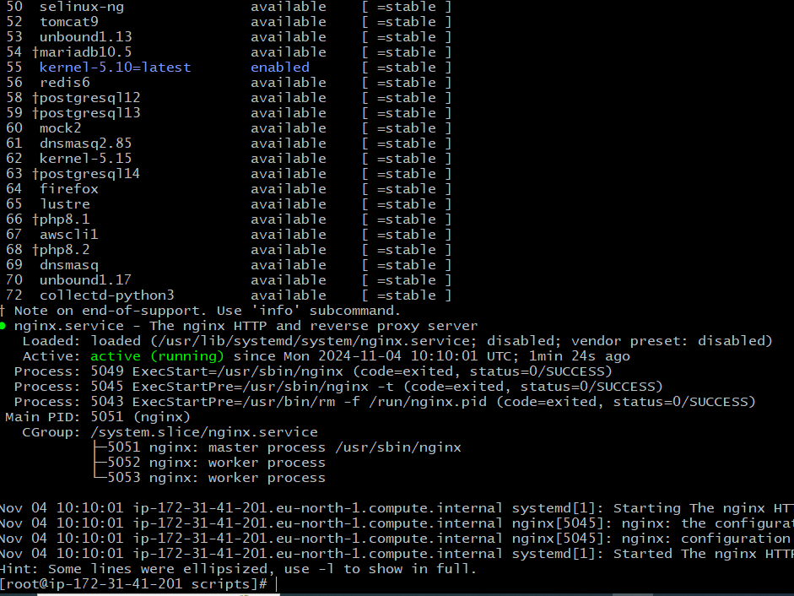

5) Create a bash script to install ApacheTomcat in ec2 server.

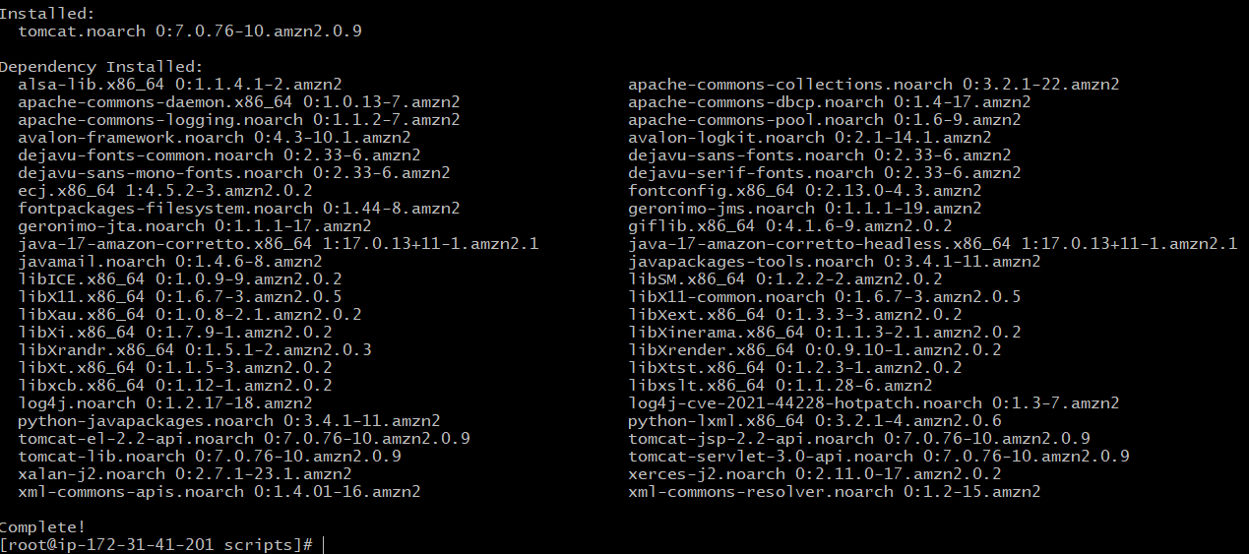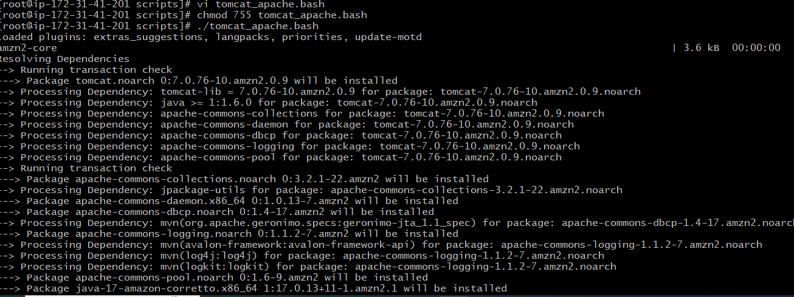

6) Create a bash script to check list if nginx service is running or not,if not running

then script should start the service.  
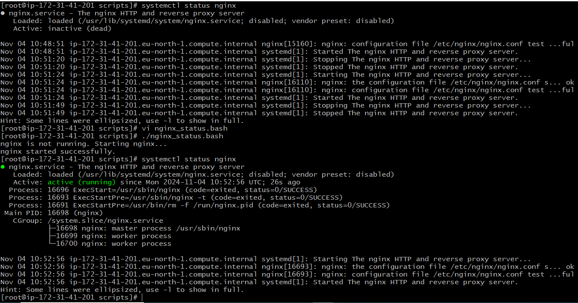

7) Create a bash script for calculator.  
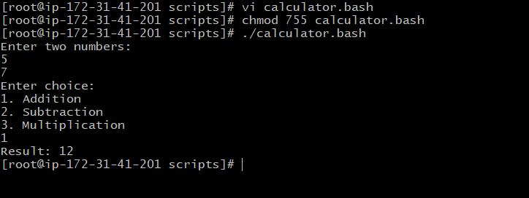

**CRONTAB**

1) April 5th Midnight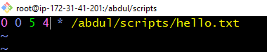

2) 5th of Every November, Jan, June if it is a Thursday.  
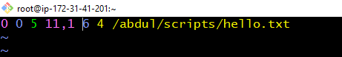

3) At 05 and 27th minutes of 9,10,11 hours everyday.

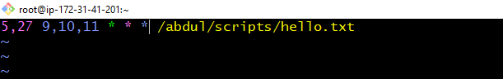

4) 34 min. of 9th hour on 15th Aug.  
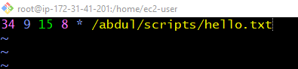

5) Every midnight  
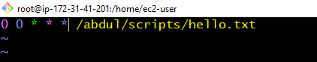

6) Every Weekend ( Saturday night 11.59 )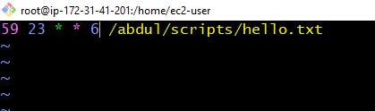

7) After every reboot  
